July 4th, 2010
Hi
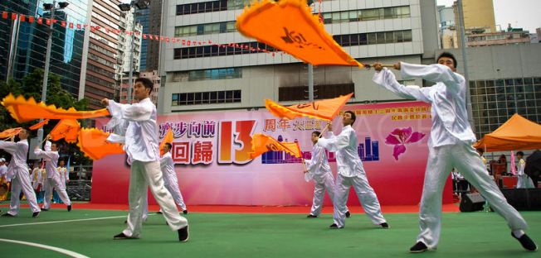
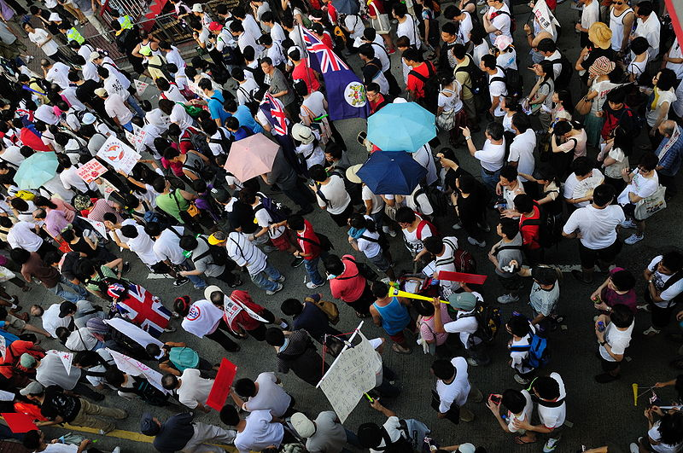
Today is the Independence Day holiday in the US, right? HK had a holiday last Thursday; July 1st, the 13th anniversary of the handover. There were the usual processions and protests. In the morning there was the flag-raising ceremony at Bauhinia Square (outside the Convention Centre) followed by a pro-government/Beijing street procession with bands, lion dances, etc. In the afternoon there was the 'pro-democracy' rally in Victoria Park followed by the street march to the Central Government offices with the usual protests (note in the pic on the right even some colonial-era British flags appeared). In this march, the Democratic Party, which last week supported the government's electoral reform package, decided to march at the end of the procession to prevent trouble, but trouble occurred anyway with members of the party being jostled and heckled. If you want to see some more pics, go to the website: http://commons.wikimedia.org/wiki/Category:2010_Hong_Kong_July_1_march
I think I have mentioned the problem of cigarette smoke coming through the bathroom ventilation system into my suite as well as smoke and appalling greasy cooking smells through the kitchen ventilation system. It seems to depend on which floors and suites the 'offenders' are on. Anyway, it was bad last weekend, so I covered the bathroom extractor fan duct with cardboard to prevent smoke entering. Although it seemed to work, I am not sure if that is the reason as the people may have moved out. It is more difficult to cover the kitchen vent as it is not flat.
Last week I did 8 km of swimming over four days. For two of those days, I swam at the deep end (to avoid the more-than-usual number of people in the main part of the pool). These swims were easier due I think, to each length being only 15 m (as against 30 m) which means that I can get a big breath at the turnarounds twice as often. So, I did not need to do any back/breast stroke in order to overcome my breath deficit. Did 2.5 km on Thursday and 2 km on Friday, though it might have been 2.3 km as I lost count due to the large number of lengths. In those cases when I lose count, I 'punish' myself by swimming extra lengths or taking any lower count that I remember.
On July 1st, a new '1+7' food labelling law came into effect. Most packaged foods must show the energy content + 7 other categories, namely, amounts of protein, total fat, saturated fat, trans fat, total carbohydrate, sugar and sodium. All the big supermarkets have complied but there are still many products in smaller shops that are not correctly labelled. Also, products are not allowed to say 'No/Low fat/sugar' unless the manufacturer can prove that this is true. I read an interesting article in the SCMP the other day on good eating. It pointed out that a century or so ago, companies had their hands full just ensuring basic foods were available. But as this is no longer the case, all the companies can do is to process/change/package foods, losing much of the nutritional value in the process. The writer also pointed out that we should avoid anything our grandmothers would not recognise as food. In a book he wrote on the subject he includes pithy little slogans such as “the whiter the bread, the sooner you're dead”. Talking about bread, I liked the breads available in NZ; much better in quality and taste than the breads we can get here.
The hot weather really arrived in HK beginning last Thursday. It rose to about 35°C near here and was 37°C or higher at Repulse Bay. The heat also killed a mini-bus driver. A new law requires mini-bus and taxi drivers to turn off idling engines at a queue when they are third or more from the front of the queue. In one mini-bus, after the driver turned off the engine, the inside temperature went up to 45°C or higher which killed him.
On July 1st, new VCs took office at CUHK and Baptist University. Unlike their predecessors, they have vowed to be politically neutral and not to join the CE's Executive Council nor any body linked to China.
On Friday, I received my new driver's license. On the same day, a passenger helicopter ditched into the harbour just after take-off on its way to Macau, as a result of what seems to have been engine failure. All 13 people were rescued. To see TVB news items on the crash, go to the following website:
http://www.youtube.com/watch?v=98uiBjw4tbU
That seems to be it for now.
Cheers

